A Comprehensive Analysis of Explainable AI-Driven Machine Learning Techniques for Network Intrusion Detection Systems

ABSTRACT
- Developed unified taxonomy of XAI enabled ML based IDS methods, categorizing them on the basis of model transparency , explanation scope, and operational objectives.
- IDS analyzed over various deployment environments (IoT,SDN,and IoMT)
- Reviews major explanation mechanism like
  - SHAP
  - LIME
  - Attention based models: artificial intelligence systems that dynamically weigh different parts of an input sequence
  - Saliency methods: techniques to highlight the most important parts of input data that influence a model's prediction
  - Rule extraction techniques: methods used to translate complex, "black-box" models (like deep neural networks or random forests) into simple, human-readable logical rules
- Also looked into the adversarial perspective
INTRODUCTION
- ML based IDS utilize detecting patterns and anomalies to flag a threat.
- Traditional IDS used rule based system to flag threats.
- ML/DL based IDS utilizes “black box” models, decision making process not easily explainable
- Lack of transparency raised concerns, leading to birth of XAI.
- XAI brings in transparency, making decisions interpretable.
- white box models have high transparency but low predictive performance.
- black box models have low transparency but high predictive power.
- TLDR: the transparency and interpretability from XAI helps in improving trustworthiness of ML/DL based IDS.
RECENT SURVEYS AND PAPER SELECTION
- Surveys from last 5 years show that work on XAI is mostly (i) domain specific (IoT, healthcare etc), (ii) Task Specific (malware detection, network traffic interpretation), or (iii) method specific (SHAP/LIME etc)
- Lack of multi domain analysis in this field
- Lacks taxonomy of IDS, XAI is used in a very generic manner
- Evaluation of XAI explanations not covered consistently
- This paper’s highlights:
  - Reviews dataset landscape
  - Classifies and systematically analyse IDS frameworks based on deployment env and explanation mechanisms employed
  - Consolidates evaluation practices by reviewing both detection performance metrics and explanation-quality measures
  - Examines XAI from an adversarial perspective, to look into vulnerabilities in XAI.
  - Cross domain XAI insights (compares IDS solutions across various domains)
BACKGROUND
- first section discusses model utilized for classifications from previous surveys
  - decision tree based (Structured/tabular & real-time IDS → Feature importance, TreeSHAP, LIME, rule extraction)
  - artificial neural network based (Nonlinear attack detection, NIDS/HIDS → SHAP, LIME, IG)
  - ML based classifiers: ensemble learning, support vector machine, linear regression, etc (Baseline/small-medium datasets, high-dimensional features → SHAP, LIME)
  - DL based classifiers: FNN,CNN,RNN,LSTM,GRU,AE,GAN (Large-scale, sequential/raw traffic, zero-day detection → SHAP, LIME, IG, Grad-CAM, counterfactuals)
- 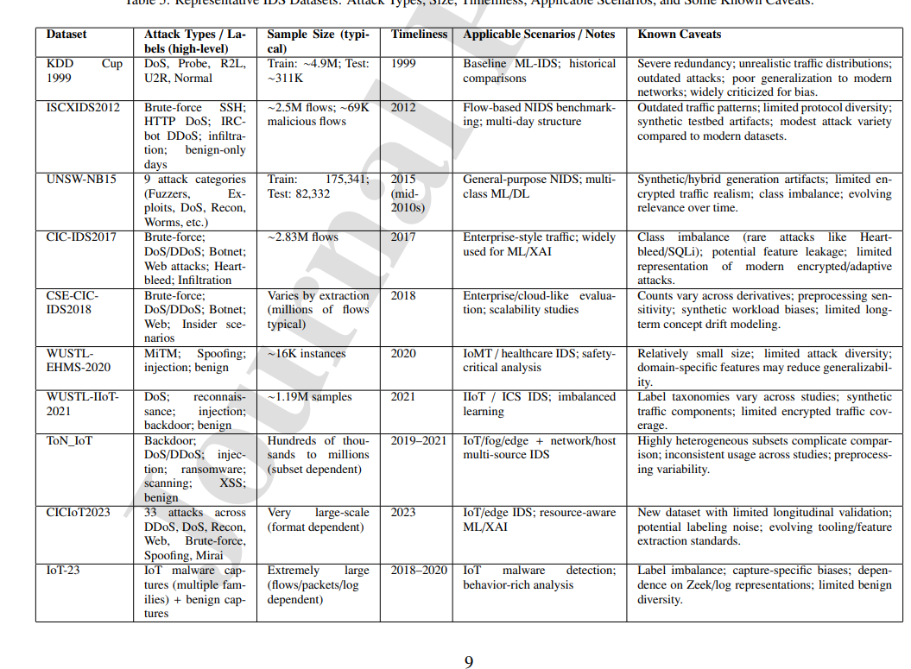
Datasets utilized to evaluate xAI enabled ML based IDS discussed in the paper
- Older datasets have important limitations such as outdated traffic patterns, redundancy and poor representation of modern attacks.
- Newer datasets provide more realistic/modern scenarios but can still suffer from class imbalance, synthetic traffic, limited attack diversity and dataset-specific biases.
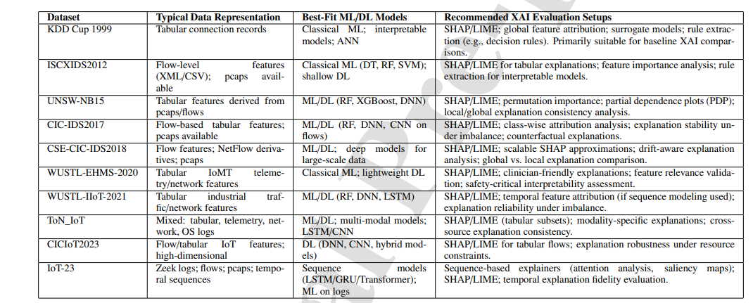

- Common explainability techniques:
  - Local explanation
  - Global explanation
  - SHAP, SHAPR, Shap-CAM, TreeSHAP, Gradient SHAP, linear SHAP, Kernal SHAP, deep SHAP
  - LIME
  - Leave one covariate out
  - Contrastive explanation method
  - Permutation feature importance
  - Saliency maps
  - Model specific techniques
  - Layer wise relevance propagation
  - DeepLIFT
  - Integrated gradients
  - Decision trees and rule extraction
  - Anchors
  - Partial dependence plots and individual conditional expectation plots
  - Counterfactual XAI techniques
XAI-Enabled Machine Learning-based Intrusion Detection Systems
- IDS Using SHAP and/or LIME
  - IDS using SHAP and/or LIME for General Computer Networks
  - Several XAI-IDS studies datasets such as KDD99, NSL-KDD and CICIDS-2017
  - Metrics used for explanation evaluation include fidelity, sparsity, stability, robustness, efficiency and completeness.
  - Since the reliance is totally on older datasets, issue here is the limited validation on modern network environment and attacks, cross dataset generalization unexplored
  - Some studies evaluate using perturbation, some using metrics like precision recall, others using explanation evaluation metrics mentioned above
  - Lack of standardized evaluation framework for XAI in IDS
  - More focused on detection performance than explanation performance.
  - Adversarial robustness and real world deployment unexplored (adversarial part can be used in out research)
  - XAI-enabled ML-based NIDS for IoT Networks
- Most commonly used models are DL based like ANN, RNN, CNN, LSTM
- Dataset mismatch is there, utilizing legacy datasets like NSL-KDD which are not meant to be utilized for IOT systems.
- XAI enabled ML based IDS in this domain is emerging towards edge deployment, federated learning, and human computer interactions.
- This domain lacks cross-dataset validation and adversarial robustness exploration
- XAI used as post hoc analysis rather than being made a part of actual training.
  - XAI-enabled ML-based IDS for IIoT Networks
Most commonly used models are CNN, LSTM, GRU, ensemble models
- DL IDS use sequential models and attention mechanisms
- XAI being combined with federated learning and edge deployment
- Use of older datasets like ToN_IoT and CICIDS2017 which may not reflect realistic industrial traffic or system constraints.
- Rare consideration towards cross validation and adversarial robustness.
- XAI used as post hoc interpretation rather than being integrated into adaptive learning.
- Local + global explanations are being explored to improve interpretability.
  - XAI-enabled ML-based IDS Designed for Vehicular Networks
- work by Lundberg is notable here due to involvement of user study improving human trust.
- Some studies used ToN_IoT dataset not suitable for vehicular networks.
- XAI here is evaluated on technical metrics, detection performance and human studies
- Dataset suitability is an issue.
  - XAI-enabled ML-based IDS for Dealing with Specific Attacks
- works are done on various types of attacks like DDoS, DNS over HTTP, Botnet detection, poisoning attack in federated learning, it also studies the defenses against adversarial manipulation.
- LIME and SHAP are used that provide local and global explanantions.
- Datasets used here are more specific to this domain (SDN-DDoS24, CIC-IoT2022, CIC-DDoS2019)
  - XAI-enabled IDS for Specialized Domains and Systems
- Studies here focused on SDN based networks and Security information and event management.
- SHAP is more dominantly used here
- Explainability is linked to analyst trust and operational usability than just transparency
NOTE: all these systems have gone though issues like lack of proper dataset to test explanability, lack of research in adversarial robustness, computational overheads and XAI merely used as a post hoc only looking for detection performance and not explanantion performance.
- IDS Using XAI Techniques Other Than SHAP/LIME
- 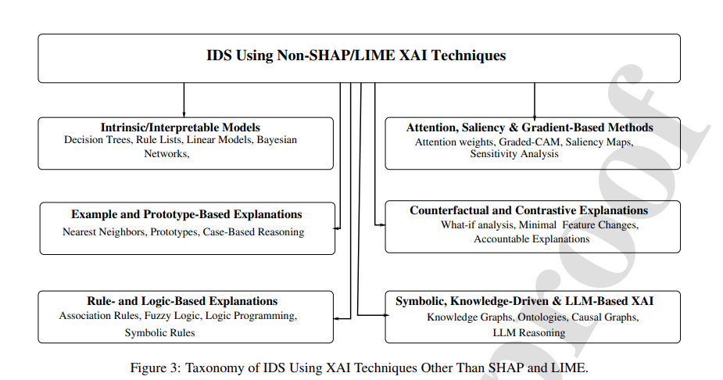

  - XAI-enabled IDS for General Computer Networks, not using SHAP or LIME
- XAI is not used as post hoc, interpretability is built into model.
- Some frameworks incorporate explanations into the IDS architecture.
- Here, the predeiction and its explanation is further directed into security actions for things like NIDS.
- Formal verification and adversarial robustness is explored.
- Explanation methods used: rule extractions, graph based explanation, knowledge graphs, formal verification.
  - XAI-enabled IDS, Designed for IoT Networks, that do not use SHAP or LIME
- focus is towards human centered, context aware and actionable explanations.
- Approaches provide both local and global explanations.
- Different explanation methods/models can perform differently depending on the dataset and attack type, suggesting that a single XAI method may not be optimal for every situation.
- Explanation methods used: permutation feature importance, ICE, partial dependence, ALE, counterfactual explanations.
  - IDS Designed for IIoT Networks, that do not use SHAP or LIME
- explains model decisions using statistical relationships between input features and model outputs.
- Some XAI systems go beyond explanation and produce actionable attack intelligence/rules that can help security analysts respond to cyber-physical attacks.
  - IDS Designed for Specific Networks, Attacks, or Problems
- Explanation outputs can be used to verify model predictions and identify potentially unreliable classifications.
- Combining feature relevance with classifier confidence can help identify false positives and reduce false alarms.
- Some explanation systems have their outputs validated by domain experts, rather than evaluating explanations only through numerical metrics.
- XAI is being combined with federated learning to provide explanations while maintaining data privacy in distributed IDS.
NOTE: in this field of explanability, XAI is not being utilized just as a post hoc implementation but is being integrated into the IDS architectecture/pipeline i.e. the training and decision making process, adversial robustness is being explored extensively by making minor perturbations, resource constraints are not being overlooked, focus is also towards federated learning and most importantly the explanations are such that they can converted into actionable security decisions.
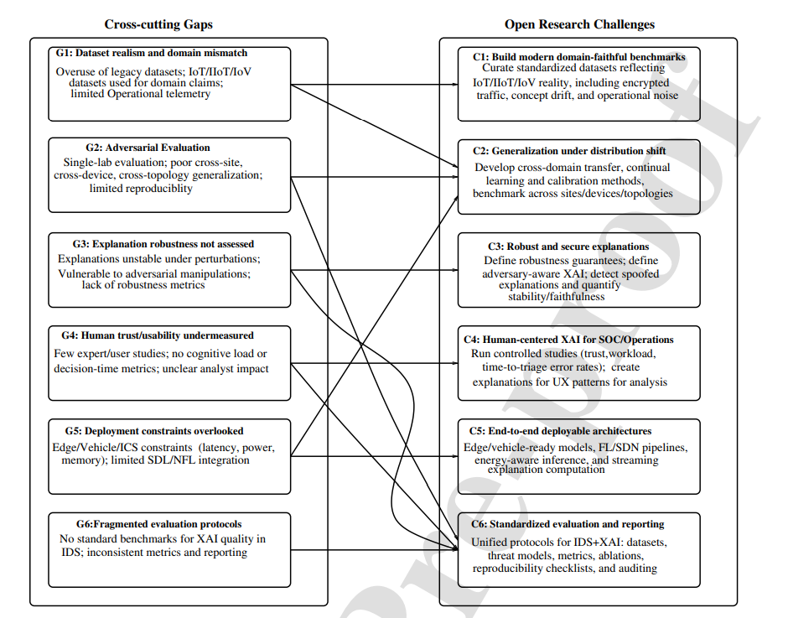
CROSS CUTTING GAPS MAPPED TO OPEN RESEARCH CHALLENGES
Metrics for Evaluating XAI-Enabled Intrusion Detection Systems
- Foundational Conceptual metrics
  - Correctness: Faithfulness of the explanation to the model’s true reasoning process
  - Completeness: Degree to which explanations capture all essential decision factors.
  - Consistency: Stability of explanations across similar inputs.
  - Continuity: Smooth variation of explanations under small input perturbations.
  - Contrastivity: Ability to explain “why this class / why not another.”
  - Covariate Complexity: Reliance on interpretable features
  - Compactness: Conciseness/sparsity of explanations
  - Composition: Structural quality of explanations.
  - Confidence: Certainty associated with predictions/explanations
  - Context: Alignment with user expertise and goals.
  - Coherence: Agreement with domain knowledge.
  - Controllability: User ability to refine/manipulate explanations.
- Quantitative metrics
  - Fidelity: Alignment between explanation and model logic
  - Robustness: Stability under perturbations/adversarial inputs
  - Relevance: Focus on influential decision features.
  - Compactness(Measured): Quantitative sparsity of explanations.
  - Consistency(Measured): Numerical similarity of explanations.
  - Continuity(Measured): Mathematical smoothness of explanation.
  - Covariate Complexity Index: Quantifies sematic simplicity.
  - Functionally Grounded Evaluation: Controlled benchmark based assessment.
- Human-Centric and Usability metrics
  - Interpretability: Human ability to understand explanations.
  - User Satisfaction: Percieved usefulness of explanations.
  - Trust: Confidence induced by explanations.
  - Human grounded evaluation: expert assessment of explanations.
  - Application grounded evaluation: impact on task performance
  - Coherence(user perspective): alignment with mental models.
  - Controllability(User Interaction): ability to explore explanations.
Open Challenges
• Lack of Standardized Evaluation Protocols: Existing studies use heterogeneous, inconsistent evaluation methods.
• Overreliance on Anecdotal Evidence: Most XAI papers rely solely on anecdotal assessments, indicating that rigorous quantitative and user-based evaluations are still rare.
• Limited Human-Centric Studies
• Difficulty Measuring Ground-Truth Faithfulness: In complex deep learning IDS models, the true internal reasoning is unknown, making correctness and fidelity hard to measure directly.
• Vulnerability to Adversarial Manipulation
• Misalignment Between Human and Model Reasoning: Explanations may appear plausible to humans while being misaligned with the model’s actual decision process, leading to misleading trust.
• Lack of Actionability Metrics for Security Operations
Adverserial Attacks on XAI enabled IDS
- Explanation methods can be manipulated even when prediction remains unchanged.
- The attack is not specific to any one XAI method, instead every method can be manipulated by minor perturbations or other adversarial attack techniques.
- Some works also explores adversarial attacks that can affect both explanation and prediction.
- Model poisoning and training data manipulation attacks also alter with explanantions.
- XAI methods such as Counterfactual explanations can be exploited to leak sensitive information and can provide unequal recourse across groups.
- explanation methods can identify influential features, which attackers can then perturb to generate adversarial examples that evade IDS/malware detectors.
- adversarial attacks can exploit XAI auditing mechanisms and manipulate explanations without substantially changing inputs.
(Research opportunity: Existing work demonstrates that XAI explanations can be manipulated under adversarial perturbations, but explanation robustness should be systematically evaluated in IDS settings cusing metrics such as explanation similarity/rank correlation, feature overlap, and prediction consistency.)

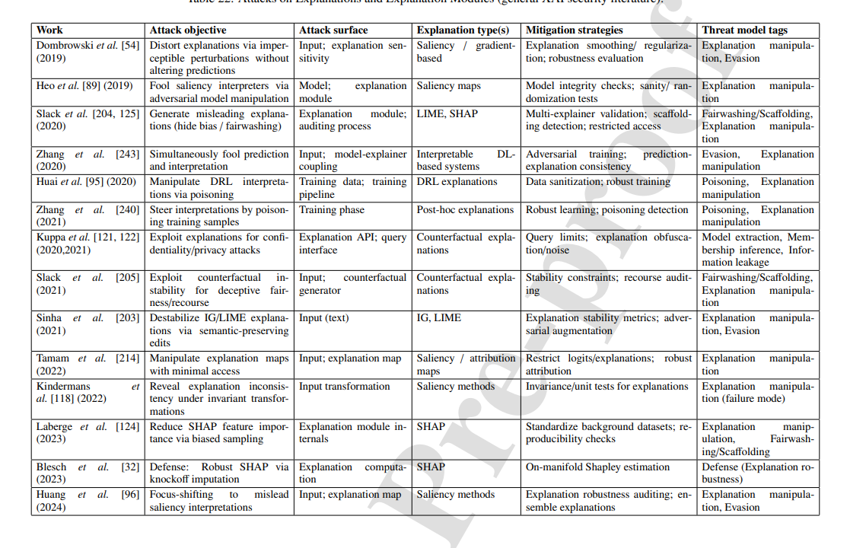
Discussion, Outstanding Issues, and Future Directions
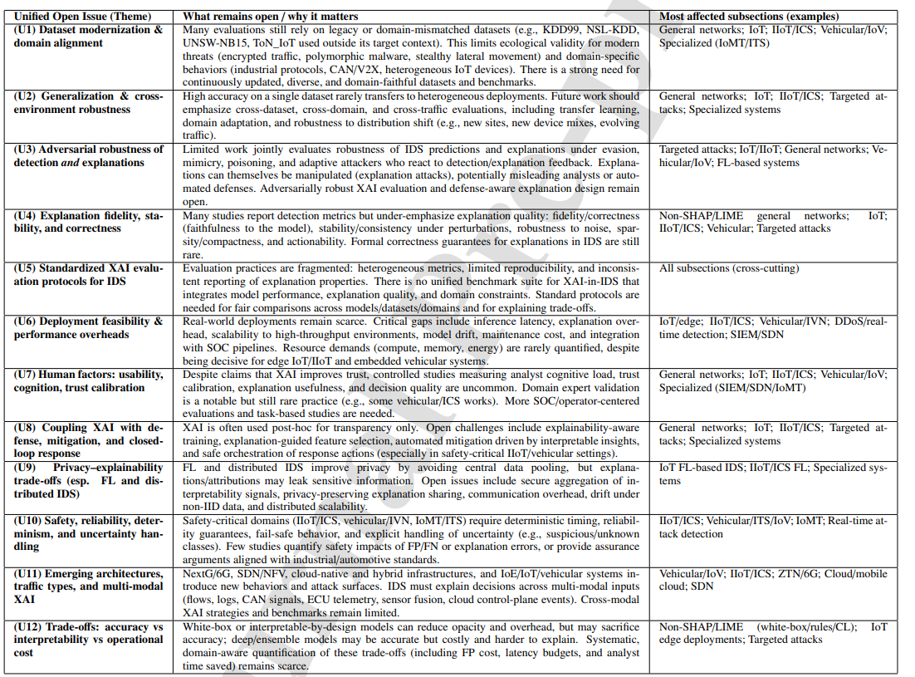
Main areas of work from our side (U3,U4,U5,U7)

